A

**Project Report On**

**Skill Orbit**

*Skill Competency Management System*

Submitted to

**RAJIV GANDHI UNIVERSITY OF KNOWLEDGE AND TECHNOLOGIES RK VALLEY**

On completion of Project–I

**Submitted By**

**S.MOMINTAJ(R200280)**

*Under the guidance of*

Mr. P. SANTHOSH KUMAR , ASSISTANT PROFESSOR

Department of Computer Science and Engineering



##### RAJIV GANDHI UNIVERSITY OF KNOWLEDGE TECHNOLOGIES(AP IIIT)

**R.K Valley, Vempalli, Kadapa(Dist) – 516330 DEPARTMENT OF COMPUTER SCIENCE AND ENGINEERING**

**2025-2026**

##### RAJIV GANDHI UNIVERSITY OF KNOWLEDGE TECHNOLOGIES (AP IIIT)

**R.K Valley, Vempalli(M), Kadapa(Dist) – 516330 DEPARTMENT OF COMPUTER SCIENCE AND ENGINEERING**

**2025-2026**



# CERTIFICATE

This is to certify that the project report entitled “***SKILL ORBIT***” being submitted by **S.MOMINTAJ** under my guidance and supervision and is submitted to **DEPARTMENT OF COMPUTER SCIENCE AND ENGINEERING** in partial fulfilment of requirements for the award of Bachelor of Technology in Computer Science during the academic year 2025-2026 and it has been found worthy of Acceptance According to the requirements of the University.

Project Guide Head of the Department

Mr. P. SANTHOSH KUMAR , Dr. CH Ratna Kumari M.Tech,

M.Tech(Ph.D ), Assistant Professor , (University Of Hyderabad),

Dept of CSE , PhD (JNTU H),

**RGUKT – RK VALLEY .** Ass. Prof . I Dept Of CSE,

**Signature : Signature :**

**Signature of External Examiner**

## ACKNOWLEDGEMENT

I wish to express our sincere thanks to various personalities who were responsible for the successful completion of the main project.

I am grateful to **Dr. CH. RATNA KUMARI,** Head of the Department, for her motivation and encouragement in completing the project in specified time.

I express my deepfelt gratitude to **Mr. P. SANTOSH KUMAR ,** internal guide for his valuable guidance and encouragement which enabled me to successful completion of project in time.

I express my sincere thanks to all other faculty members of CSE Department for extending their helping hands and valuable suggestion when in need.

Finally, my heartfelt thanks to my parents for giving me all I ever needed to be a successful student and individual. Because of their hard work and dedication, I have had opportunities beyond my wildest dreams.

**WITH SINCERE REGARDS**

**S.MOMINTAJ [ R200280]**

# DECLARATION

Hereby declare that this project work entitled **“*SKILL ORBIT*”**

submitted to **DEPARTMENT OF COMPUTER SCIENCE AND ENGINEERING** is

a genuine work carried out by me, for the fulfilment of Bachelor of Technology in the Department of Computer Science & Engineering during the academic year 2025-2026 under the supervision of my project guide **Mr. P. SANTOSH KUMAR ,** Department of **Computer Science & Engineering** in **RAJIV GANDHI UNIVERSITY OF KNOWLEDGE TECHNOLOGIES(AP IIIT), R.K. Valley .**

**WITH SINCERE REGARDS**

**S.MOMINTAJ [ R200280]**

**ABSTRACT**

The traditional approach to employee skill management and training often suffers from inefficiencies, lack of centralized tracking, and communication barriers between managers and employees. To overcome these challenges, **Skill Orbit – Skill Competency Management System** has been developed as an intelligent platform designed to streamline and enhance the overall skill development process. The system integrates modern web technologies with structured competency frameworks to automate training workflows, enable skill gap analysis, and provide data-driven insights into employee performance and growth.

The platform is built using an **Angular** frontend and a **FastAPI** backend, ensuring scalability, security, and responsiveness. It supports competency tracking across standardized levels (**L1–L5**) aligned with CASCADE and MHS frameworks, and includes modules such as training catalog management, assignment tracking, feedback collection, and role-based dashboards for managers and engineers. The solution enables seamless interaction between managers and employees, improves training efficiency, and facilitates performance evaluation through real-time analytics and automation.

The implementation of **Skill Orbit** demonstrates significant improvement in training management, enhanced employee engagement, and streamlined coordination between team members and supervisors. The system not only simplifies competency tracking but also represents a modern, data-driven approach to human resource development. Future enhancements aim to incorporate machine learning–based training recommendations, multi-language support, and predictive analytics for proactive skill gap identification.

**INTERNSHIP DESCRIPTION**

I am currently pursuing my internship at **ZF Group** as part of my academic curriculum. This internship has provided me with a valuable opportunity to gain practical experience in the field of **software development** and **enterprise application design**. Working in a professional environment has helped me bridge the gap between theoretical knowledge and real-world implementation.

During my internship, I have been working on the project titled **“Skill Orbit – Skill Competency Management System”**, which is also being presented as my major project for the fulfillment of my undergraduate degree requirements. The project is being developed under the mentorship of experienced professionals at **ZF Group**, who have guided me throughout the stages of system design, development, and testing.

**ZF Group** is a global technology company that specializes in mobility solutions, automotive systems, and industrial technology. The organization focuses on developing innovative products for vehicle motion control, electric mobility, and digital transformation. Being part of such a dynamic work environment has significantly enhanced my understanding of **software engineering practices**, **collaborative development**, and **problem-solving** in large-scale systems.

The **Skill Orbit** platform developed during this internship aims to modernize and automate the skill management and training process within organizations. It integrates modules such as skill tracking, role-based dashboards, training catalog management, feedback collection, and competency analysis using structured frameworks. My contribution primarily involved designing the **system architecture**, developing the **frontend using Angular**, building the **backend services with FastAPI**, and integrating APIs to ensure smooth data communication between components.

This report represents the complete documentation of the project undertaken during my internship at **ZF Group**, demonstrating how academic learning has been effectively applied to build an innovative, industry-oriented solution that supports efficient and data-driven skill management.

**OFFER LETTER**

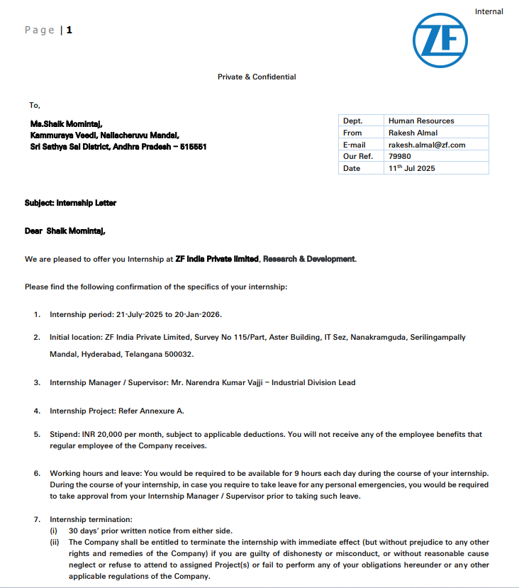

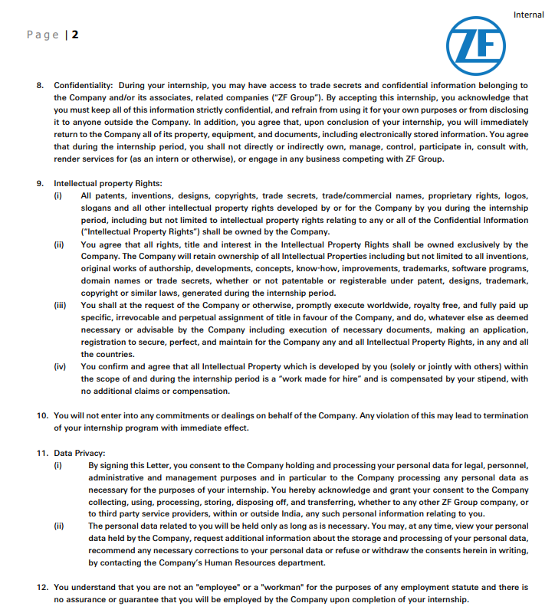

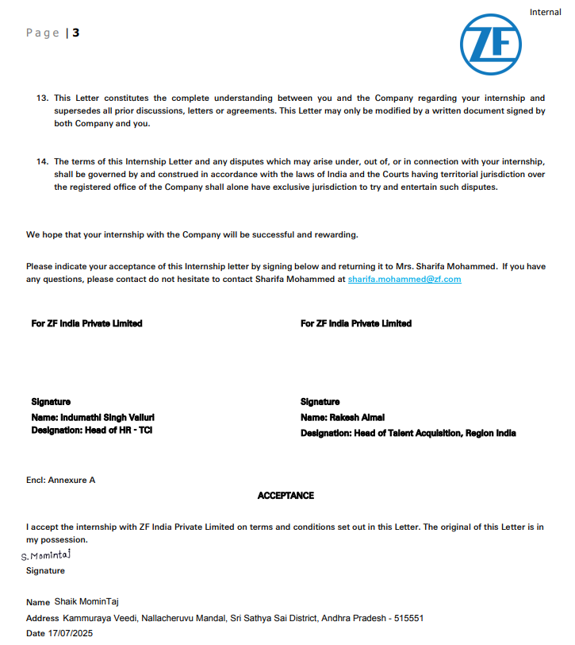

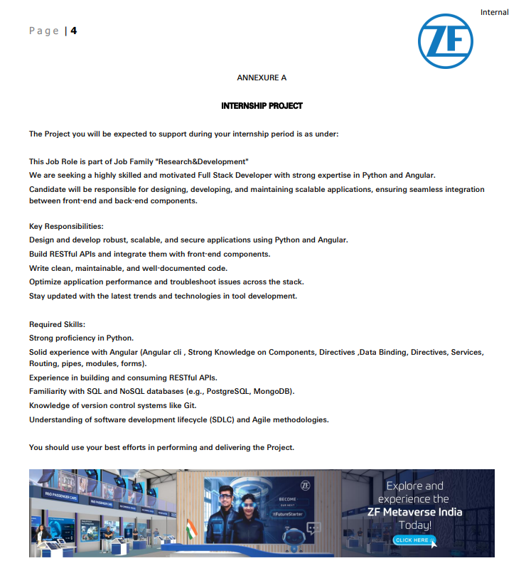

**Table Of Contents**

|  |  |  |
| --- | --- | --- |
| **Serial No .** | **Title** | **Page No** |
| 1 | TITLE | I |
| 2 | CERTIFICATE | II |
| 3 | ACKNOWLEDGEMENT | III |
| 4 | DECLARATION | IV |
| 5 | ABSTRACT | V |
| 6 | INTERNSHIP DECLARATION | VI-X |
| 7 | Chapter 1 : INTRODUCTION | 2-6 |
| 8 | Chapter 2 : MODEL BUILDING AND  DEVELOPMENT | 7-10 |
| 9 | Chapter 3 : TESTING AND VALIDATION | 11-12 |
| 10 | Chapter 4 : IMPLEMENTATION AND RESULTS | 13-24 |
| 11 | Chapter 5 : FUTURE ENHANCEMENTS AND  IMPROVEMENTS | 25 |
| 12 | Chapter 6 : CONCLUSION | 26 |
| 13 | Chapter 7 : REFERENCES | 27 |

**List Of Figures**

|  |  |  |
| --- | --- | --- |
| **Figure No.** | **Figure Name** | **Page No.** |
| 1 | **Home page** | 14 |
| 2 | **Registration Page** | 15 |
| 3 | **Login Page** | 16 |
| 4 | **Engineer Dashboard** | 17 |
| 5 | **Manager Dashboard** | 17 |
| 6 | **About Page** | 18 |
| 7 | **My Skills Module Page** | 19 |
| 8 | **Training Catalog Page** | 19 |
| 9 | **Assigned Trainings Page** | 20 |
| 10 | **My Badges Page** | 20 |
| 11 | **Assign Training Page** | 21 |
| 12 | **Team Skills Page** | 21 |
| 13 | **Levels Page** | 22 |
| 14 | **My Requests Page** | 23 |
| 15 | **Team Dashboard Page** | 23 |

**Chapter – 1**

**INTRODUCTION**

The rapid growth of digital technologies, automation, and data-driven systems has significantly transformed how organizations manage workforce skills. Traditional methods such as manual tracking and spreadsheets often result in inefficiencies, data duplication, and limited visibility into employee competencies. As industries evolve with emerging technologies, the need for structured, measurable, and data-driven skill management systems has become crucial.

**Skill Orbit – Skill Competency Management System** is developed to overcome these challenges by providing an intelligent, automated, and centralized platform for managing employee skills and training. The platform ensures a structured and data-driven approach to workforce development through competency-based tracking, automated training assignments, performance evaluation, and real-time analytics. It bridges the communication gap between managers and employees by offering role-based dashboards, structured feedback mechanisms, and integrated workflows for training and development.

The system leverages an **Angular**-based frontend for a responsive and interactive user experience and a **FastAPI** backend for handling secure and scalable business logic. A **PostgreSQL** database ensures reliable data storage, while authentication and authorization mechanisms protect sensitive employee data. Furthermore, the platform incorporates **CASCADE** and **MHS** competency frameworks to assess employee proficiency across five levels (L1–L5), ensuring standardized evaluation across teams.

By combining automation, structured competency tracking, and analytics, **Skill Orbit** transforms the traditional manual skill management process into a modern, intelligent ecosystem. It enables managers to make informed decisions, track team growth, and ensure that training programs are aligned with organizational objectives. At the same time, it empowers employees to monitor their own progress and engage in continuous skill enhancement.

In short, **Skill Orbit** represents a shift from conventional training methods to a comprehensive, technology-driven competency management model that promotes efficiency, transparency, and continuous learning

**1.1 INTRODUCTION TO INTERVIEWEASE**

Skill management plays a critical role in every organization’s success, particularly in the technology-driven world where skill requirements evolve constantly. Conventional systems lack centralized tracking, clear visibility, and a standardized framework for evaluating skills. To address these challenges, **Skill Orbit** introduces a streamlined and intelligent competency management system designed to modernize how organizations manage workforce capabilities.

**Skill Orbit** enables managers and employees to collaborate efficiently through an intuitive digital platform. Employees can view their skill sets, identify competency levels, and track progress from **L1 to L5** based on standardized frameworks. Managers, on the other hand, can view team competencies, assign relevant trainings, and monitor overall skill development using analytical dashboards. The system also includes modules for training catalogs, feedback collection, and skill gap analysis, ensuring that both employee growth and organizational development move in sync.

Developed using **Angular** for the frontend and **FastAPI** for the backend, the system ensures a fast, secure, and scalable architecture. The use of **PostgreSQL** as a database supports efficient data handling, while API integration ensures seamless communication between components. The modern UI, combined with structured logic and automation, creates a highly user-friendly experience suitable for enterprise-level deployment.

By introducing structured competency mapping and automation, **Skill Orbit** transforms traditional skill management into a smart, data-driven process that improves training efficiency, reduces manual effort, and enhances collaboration between teams

**1.2 PROBLEM STATEMENT AND OBJECTIVES**

**Problem Statement:**

Traditional skill management and training systems in organizations often rely on manual methods that are time-consuming, error-prone, and lack standardization. The absence of structured competency frameworks and real-time tracking results in unclear performance insights and limited opportunities for targeted development. Communication gaps between managers and employees further delay training decisions and hinder effective progress evaluation.

There is a need for an intelligent, automated, and centralized system that standardizes competency tracking, simplifies training management, and leverages data analytics for better decision-making in employee development.

**Project Objectives:**

* To design and develop a **full-stack web platform** using Angular and FastAPI for skill and competency management.
* To implement **structured competency tracking** using **L1–L5 levels** aligned with **CASCADE and MHS standards**.
* To create **role-based dashboards** for managers and employees with controlled access and personalized features.
* To provide **automated training management**, including assignment, feedback, and tracking modules.
* To analyze **skill gaps and progress trends** using data-driven insights and analytics.
* To ensure **secure authentication** and **role-based authorization** for all users.
* To develop a **user-friendly and responsive interface** for seamless navigation and accessibility.
* To deploy and validate the platform for **real-time performance** and scalability.

**1.3 APPLICATIONS AND SCOPE**

**APPLICATIONS**

The Skill Orbit – Competency Management Ecosystem can be effectively applied in various domains where skill tracking, training, and performance evaluation are essential. The major areas of application include:

* **Corporate Organizations:**  
  Enables human resource and training departments to monitor employee skills, assign trainings, and evaluate competency levels efficiently.
* **IT and Software Companies:**  
  Assists technical managers in assessing employee skill gaps, planning training programs, and tracking team performance using standardized competency frameworks.
* **Educational Institutions:**  
  Facilitates skill-based learning and training management for students, allowing institutions to evaluate competencies through structured assessments.
* **Consultancy and Professional Services:**  
  Helps consultancy firms manage workforce skill data, plan upskilling programs, and maintain client-oriented performance records.
* **Government and Public Sector Organizations:**  
  Ensures transparency and uniformity in training programs and competency evaluations across different departments.
* **Research and Development Institutions:**  
  Provides structured frameworks to identify key skills required for innovation and project-specific technical advancement s.

**Scope for Research and Development:**

The **Skill Orbit** platform is developed with a scalable and modular architecture, allowing easy expansion and integration of advanced technologies in the future. The possible areas for enhancement include:

* Integration of **Machine Learning (ML)** models to provide personalized training recommendations based on user skill profiles and career growth paths.
* Implementation of **Predictive Analytics** to forecast future skill requirements and training needs within an organization.
* Development of a **Mobile Application** to provide on-the-go access for users to track skills, manage trainings, and submit feedback.
* Integration with external systems such as **Learning Management Systems (LMS)**, **Human Resource (HR)** platforms, and collaboration tools like Microsoft Teams or Slack.
* Addition of **Multi-Language Support** to make the system adaptable for global organizations.
* Introduction of **Gamification Features** such as badges, progress tracking, and leaderboards to enhance user engagement and motivation.

• Addition of **AI-driven bias detection modules** to ensure fair and ethical recruitment practices.

**Conclusion of Introduction**

In conclusion, **Skill Orbit –Skill Competency Management System** provides a modern, intelligent, and automated solution for managing employee training and development. By integrating technology, analytics, and standardized competency frameworks, it empowers organizations to build a more skilled, efficient, and future-ready workforce. The system’s modular design, secure architecture, and data-driven insights make it an essential tool for the digital transformation of talent and skill management processes.

**Chapter – 2**

**MODEL BUILDING AND DEVELOPMENT**

The main objective of **Skill Orbit – Competency Management Ecosystem** is to design and build a full-stack competency management system that simplifies and enhances employee development through automation, real-time tracking, and intelligent evaluation. The platform integrates modules such as skill tracking, training catalog management, assignment systems, role-based dashboards, and feedback collection to support both managers and employees in a secure and scalable environment.

The development process included five major stages:

1. Gathering system requirements and platform specifications
2. Frontend design and implementation
3. Backend development with business logic and database integration
4. Database schema design and data import functionality
5. Deployment, integration, and testing

Each stage was implemented carefully to ensure the system is modular, efficient, and user-friendly..

**2.1 Gathering Requirements & Data Sources**

Before development, system requirements were gathered by analyzing workflows of managers and employees. The requirements were categorized into functional and non-functional aspects.

**Functional Requirements**

• **User roles**: Engineer, Manager, Administrator, Trainer

• **Skill data:** Employee competencies with current and target levels (L1-L5), additional self-reported skills

• **Training data:** Training catalog with details, prerequisites, trainers, schedules, and assignments

**• Assignment data:** Training assignments, submissions, scores, and feedback

• **Manager-employee relationships:** Hierarchical structure for team management

**• Notification data:** Training assignments, approvals, and reminders

**Non-Functional Requirements**

* Performance: The system should ensure minimal latency and smooth operations for multiple users.
* **Scalability:** Must support an increasing number of users and data volume.
* **Security:** Password encryption and token-based authentication for user safety.
* **Usability:** Simple, interactive, and responsive user interface for all user roles.
* **Reliability:** Consistent data accuracy and integrity across all modules.

**2.2 System Architecture and Design**

The **Skill Orbit** platform follows a **three-tier architecture** comprising the

frontend, backend, and database layers.

* **Frontend (Angular):**  
  Handles user interactions and presents dynamic dashboards for managers and employees.
* **Backend (FastAPI):**  
  Manages authentication, training assignments, feedback collection, and data communication between the frontend and database.
* **Database (PostgreSQL):**  
  Stores user information, skill levels, training details, assignment data, and feedback records securely.

**Architecture Flow:**

User → Frontend (Angular) → Backend APIs (FastAPI) → Database (PostgreSQL) → Response → Frontend Display

This architecture ensures modularity, scalability, and efficient communication between all components.

**2.3 Frontend Implementation**

The frontend was built to deliver a smooth and intuitive user experience using reusable UI components.

**Key modules include:**

* **Authentication:**  
  Login and registration pages for managers and employees with validation and role-based routing.
* **Engineer Dashboard:**  
  Allows employees to view skill levels, browse training catalog, submit assignments, and track progress.
* **Manager Dashboard:**  
  Enables managers to view team skills, assign trainings, approve requests, and give feedback.
* **Skill Management Module:**  
  Displays skills with L1–L5 levels, skill gaps, and additional self-reported skills.
* **Training Catalog Module:**  
  Lists available trainings with search and filter options.
* **Assignment and Feedback Module:**  
  Manages assignment submissions, scoring, and structured feedback collection.

The frontend uses **Angular Material** and **Tailwind CSS** for creating a visually appealing interface and responsive layouts.

**2.4 Backend Implementation**

The backend is developed using **FastAPI**, chosen for its high performance,

security, and easy integration with modern frontend frameworks.

**Key Backend Services**

* **User Service:** Handles registration, login, and role-based access with JWT authentication.
* **Skill Service:** Manages employee competencies, tracks levels, and performs skill gap analysis.
* **Training Service:** Maintains training catalog, assignments, and scheduling.
* **Assignment Service:** Handles assignment creation, submission, scoring, and retrieval.
* **Manager Service:** Tracks team performance, manages training approvals, and stores feedback.
* **Feedback Service:** Collects and stores user feedback for performance evaluation.
* **Data Import Service:** Enables uploading of Excel or CSV files for bulk data import (trainings, employees, competencies).

**Technologies Used:**  
 FastAPI, PostgreSQL, SQLAlchemy ORM, Pydantic models, JWT for authentication, and Bcrypt for password encryption.

**Data Flow:**

Frontend Request → FastAPI Endpoint → Database Operation → Response → Frontend Update

This ensures seamless and secure communication between all modules.

**2.5 AI Evaluation and Visualization**

The **Skill Orbit** system ensures seamless data flow between the Angular frontend and FastAPI backend using **RESTful APIs**. All major operations—such as authentication, training management, and feedback submission—are handled through secure API calls.

The frontend communicates with the backend using HTTP methods (**GET**, **POST**, **PUT**, **DELETE**) and receives JSON responses for real-time updates. **JWT authentication** and **CORS configuration** are implemented to ensure secure communication and controlled data exchange.

This integration enables reliable, fast, and efficient communication between all modules of the system.

**Conclusion of Model Building and Development**

The design and development phase of **Skill Orbit – Competency Management Ecosystem** was executed using a structured, modular, and scalable approach. The combination of **Angular**, **FastAPI**, and **PostgreSQL** ensures a secure, efficient, and interactive platform for both managers and employees.

Each module—from skill management to feedback collection—was developed to work in synchronization, enabling seamless data flow and improved user experience. The system design supports future enhancements such as machine learning-based recommendations, predictive analytics, and mobile application integration, making **Skill Orbit** a reliable and adaptable platform for modern competency management.

**Chapter - 3**

## TESTING AND VALIDATION

## 

## Testing and validation are essential phases in ensuring that the Skill Orbit – Skill Competency Management System performs as expected and fulfills all the defined requirements. The system was tested at different stages of development to identify and fix errors, verify functionality, and ensure stability before deployment.

**3.1 Testing**

Testing was performed at multiple levels to ensure that the **Skill Orbit** platform operates smoothly and efficiently. The testing phase focused on verifying both the **frontend (Angular)** and **backend (FastAPI + PostgreSQL)** functionalities, along with the overall integration between modules.

* **Frontend Testing:**  
  Verified login, registration, dashboard navigation, skill tracking, training catalog, assignment, and feedback modules. Checked responsiveness and compatibility across browsers.
* **Backend Testing:**  
  Ensured all APIs function correctly, authentication using JWT works securely, and data is stored and retrieved properly from the PostgreSQL database.
* **Integration Testing:**  
  Verified smooth communication between Angular frontend and FastAPI backend through RESTful APIs, ensuring accurate data exchange and synchronization.

Overall, all modules were tested successfully, and the system functioned without major

errors.

**3.2 Validation**

Validation ensures that the system meets the objectives and performs according to user expectations. The system was validated by cross-checking every feature with the requirements gathered during the design phase.

* Verified competency tracking (L1–L5) for accurate skill representation.
* Checked role-based dashboards for managers and employees.
* Confirmed proper data flow across modules like training assignments and feedback.
* Conducted user acceptance testing to ensure usability and responsiveness.

The system met all validation requirements and delivered consistent, expected results across modules.

**3.3 Reliability Measures**

To maintain reliability and stability, several measures were implemented during development:

* Error handling for invalid inputs and failed API calls.
* Data validation on both frontend and backend.
* Secure authentication with encrypted passwords using **Bcrypt** and token-based access using **JWT**.
* Cross-browser compatibility and responsive design checks.
* Database integrity maintained through transaction management.

**Conclusion**

The testing and validation of Skill Orbit – Competency Management Ecosystem confirmed that all major functionalities—including user authentication, skill tracking, training management, assignment handling, and feedback collection—are working effectively. The platform performs reliably, securely, and efficiently, demonstrating readiness for real-world implementation.

**CHAPTER-4**

## IMPLEMENTATION AND RESULTS

The **Skill Orbit – Competency Management Ecosystem** is a full-stack web-based application designed to automate and streamline the process of skill tracking, training management, and performance evaluation. It provides a centralized platform for both engineers and managers to monitor skills, assign trainings, and track overall competency growth.

This chapter presents the implementation details of each module along with the outcomes of the developed system.

**4.1 Implementation Overview**

The system implementation involved both frontend and backend development, ensuring

smooth communication between all components.

* **Frontend:** Angular
* **Backend:** FastAPI (Python)
* **Database:** PostgreSQL
* **Styling:** Tailwind CSS, Angular Material
* **Authentication:** JWT-based secure login
* **Deployment:** Modular, API-driven architecture

The platform includes two main dashboards one for **Engineers** and another for **Managers**,

both sharing common features and additional role-specific modules.

**Home page:**

* Provides a clean and simple interface for first-time users.
* Shows quick access to login or register options.
* Highlights the purpose of the Skill Orbit platform.
* Offers a smooth navigation flow to begin using the system

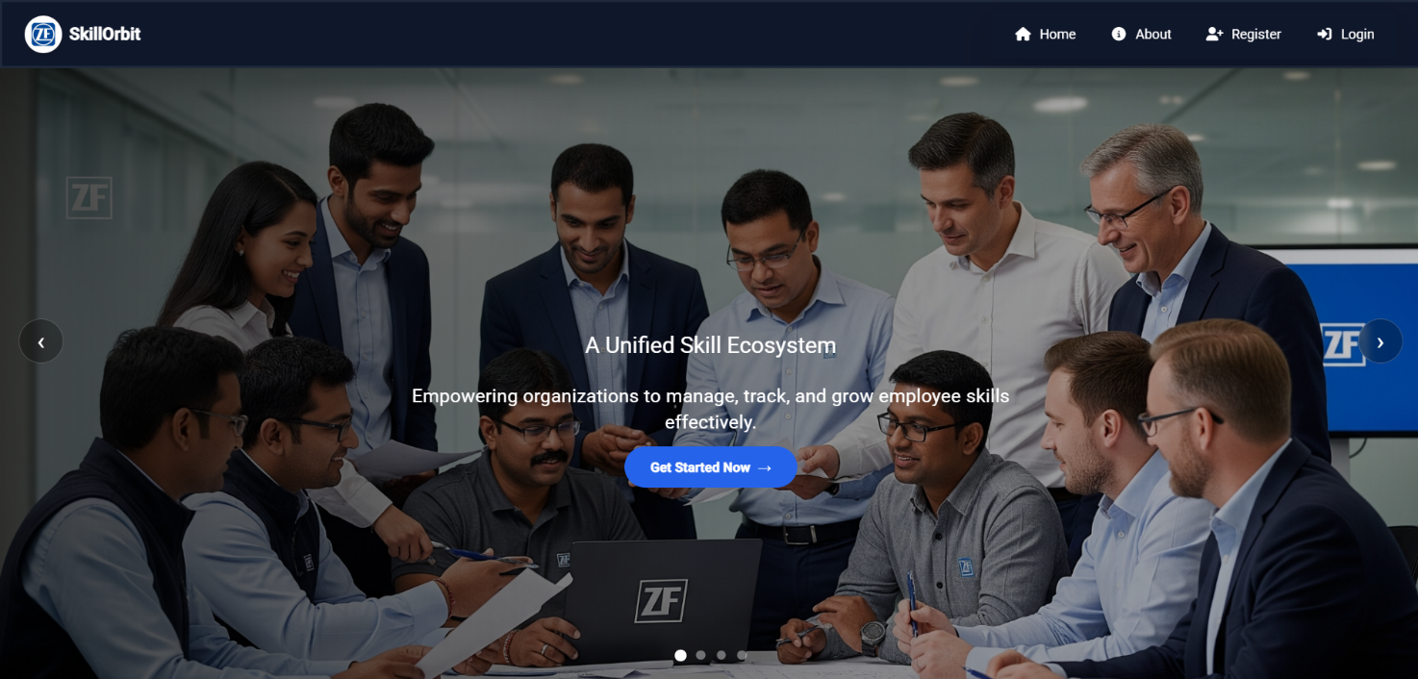

**Fig 1:Home page**

**4.2 System Architecture**

The architecture of Skill Orbit follows a client–server model, ensuring scalability and security.

* The Angular frontend provides a responsive and user-friendly interface.
* The FastAPI backend handles all business logic and communicates with the PostgreSQL database.
* JWT authentication ensures secure access to the system.

**Architecture Flow:**  
User → Frontend (Angular) → Backend (FastAPI) → Database (PostgreSQL)

**4.3 Major Modules**

The system is divided into multiple modules that together form an integrated and intelligent competency management platform:

**4.3.1 User Authentication Module**

This module provides secure login and registration functionality for users.

* Users can sign up using their employee ID and password.
* JWT-based authentication is implemented for secure sessions.
* Role-based routing ensures users are directed to the correct dashboard after login

**Registration Page:**

* Enables new users to create an account with required details.
* Supports role selection to ensure personalized access.
* Stores user information securely in the database.

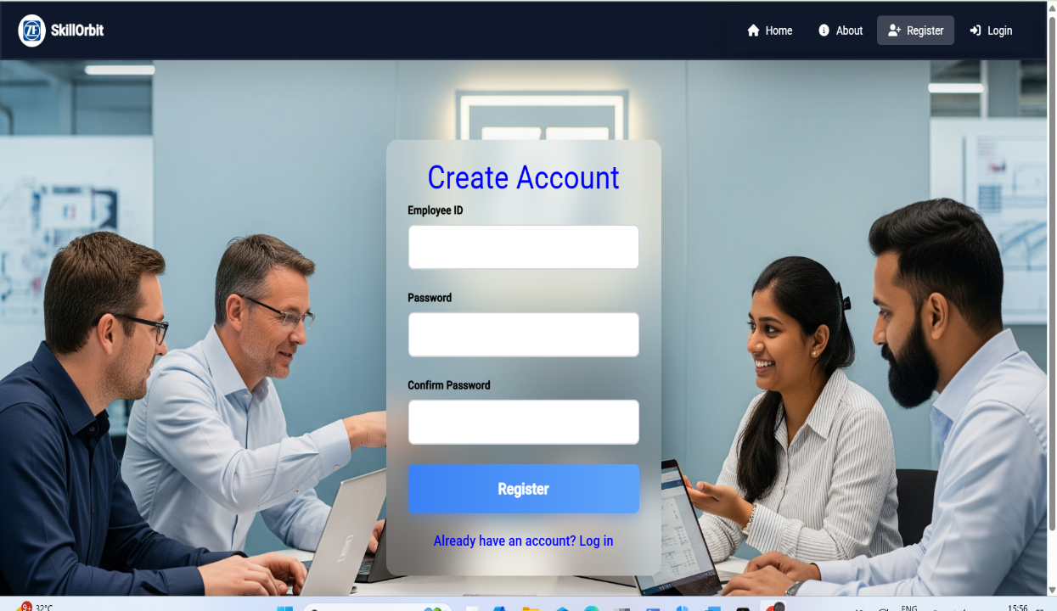

**Fig 2: Registration Page**

**Login Page:**

* Allows existing users to sign in securely using their credentials.
* Redirects users to their role-based dashboard (Manager / Engineer).
* Ensures authentication using JWT tokens for protected access.

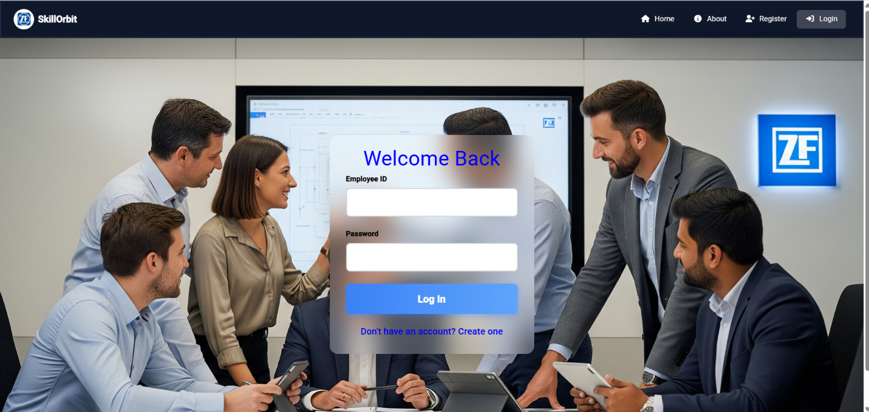

**Fig 3: Login Page**

**4.3.2 Engineer Dashboard Module**

The **Engineer Dashboard** serves as the main interface for employees. It provides access to key modules such as skill management, training catalog, assigned trainings, and badges.

**Features:**

* View and manage personal skill levels.
* Access the training catalog and request new trainings.
* Check assigned trainings and their completion status.
* Track earned badges and achievements.

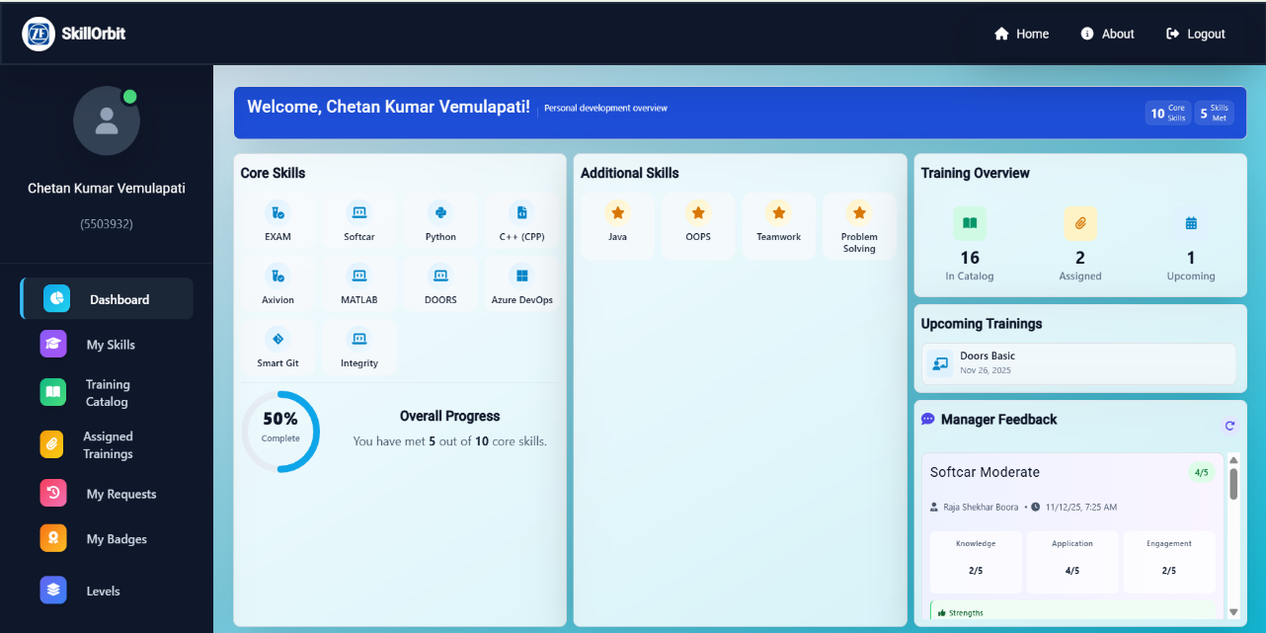

**Fig 4: Engineer Dashboard**

**4.3.3 Manager Dashboard Module**

The **Manager Dashboard** provides managers with tools to monitor their team’s performance, assign trainings, and review progress.

**Features:**

* View team skills and competency levels.
* Assign or approve trainings for engineers.
* Monitor assigned trainings and feedback.
* Access personal skill and badge sections.

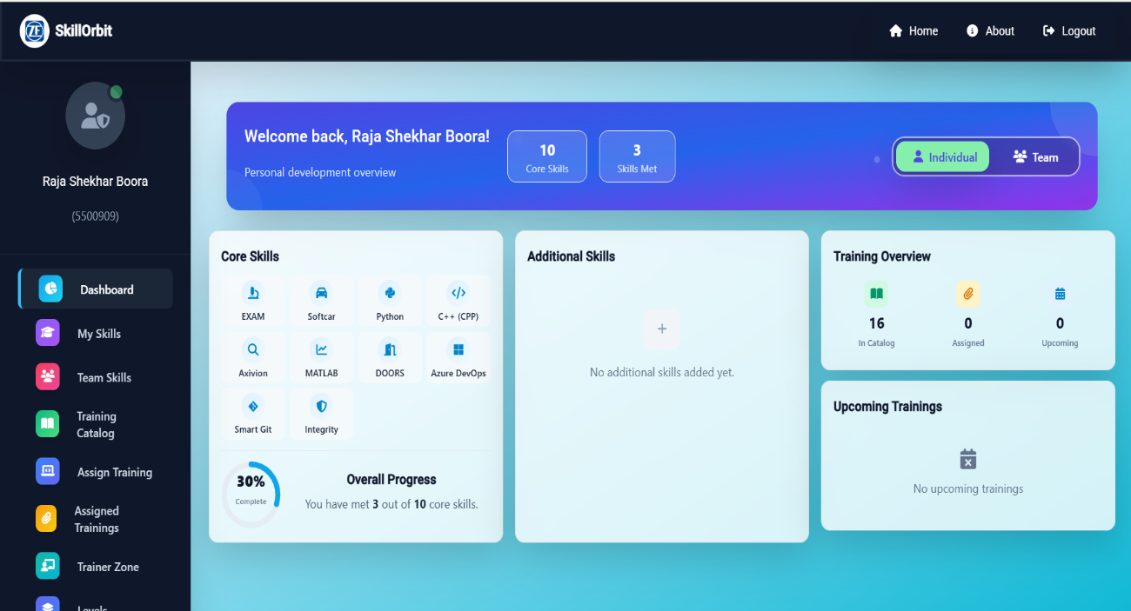

**Fig 5: Manager Dashboard**

**4.3.4 About Page**

The About Page gives users an overview of the Skill Orbit platform, explaining its purpose, features,and objectives.  
 It helps users understand how the system supports skill management and training coordination**.**

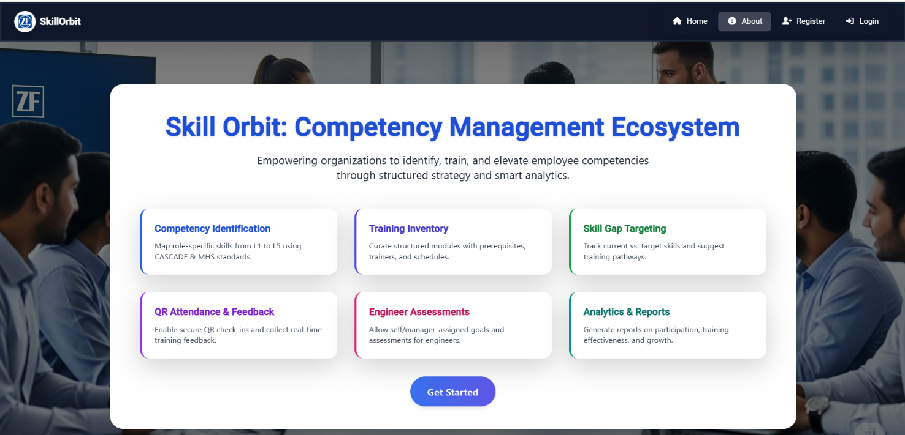

**Fig 6: About Page**

**4.3.5 My Skills Module**

This module allows users to view and update their skill details.

* Skills are displayed with current and target levels.
* Engineers can track their progress visually.
* Managers can review skill gaps across their team.

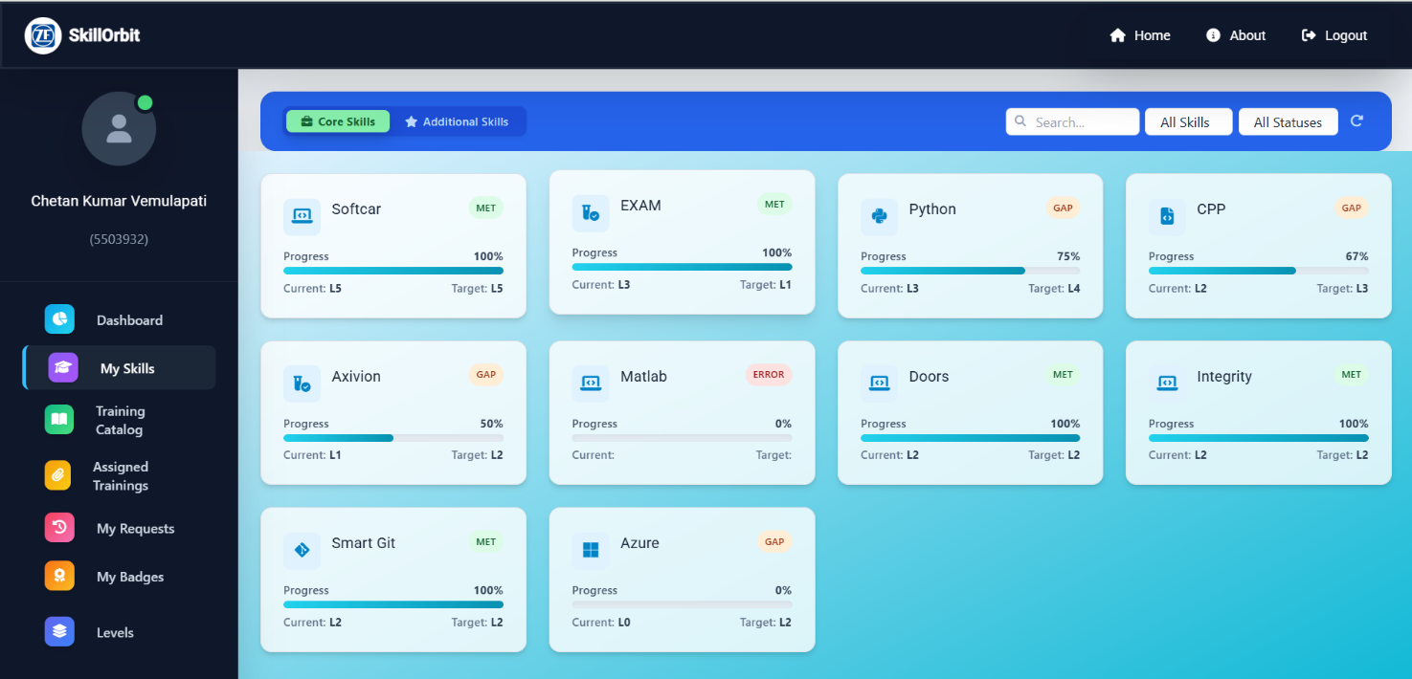

**Fig 7: My Skills Module Page**

**4.3.6 Training Catalog Module**

This section lists all available training programs in the organization.

* Users can browse, filter, and select trainings based on skills or levels.
* Each training displays title, trainer, schedule, and description.
* Engineers can request trainings, and managers can approve or assign them.

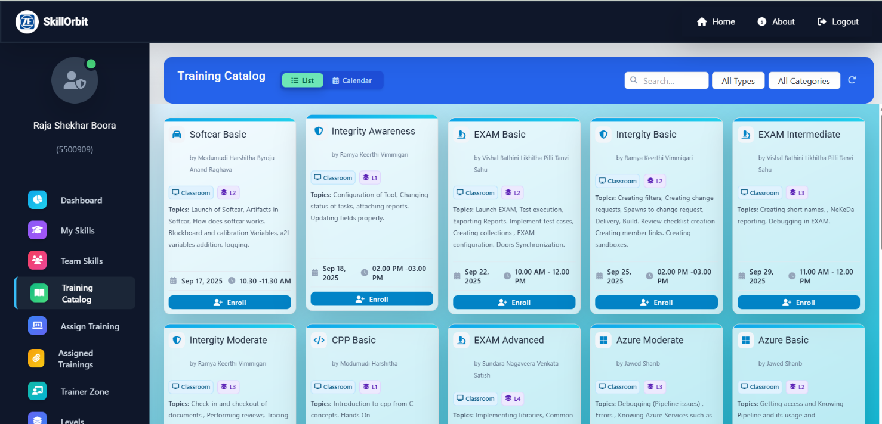

**Fig 8: Training Catalog Page**

**4.3.7 Assigned Trainings Module**

This module displays all trainings assigned to the user.

* Users can check the training name, schedule, and completion status.
* The progress bar shows how much of the training has been completed.
* Managers can view assigned trainings for their team members.

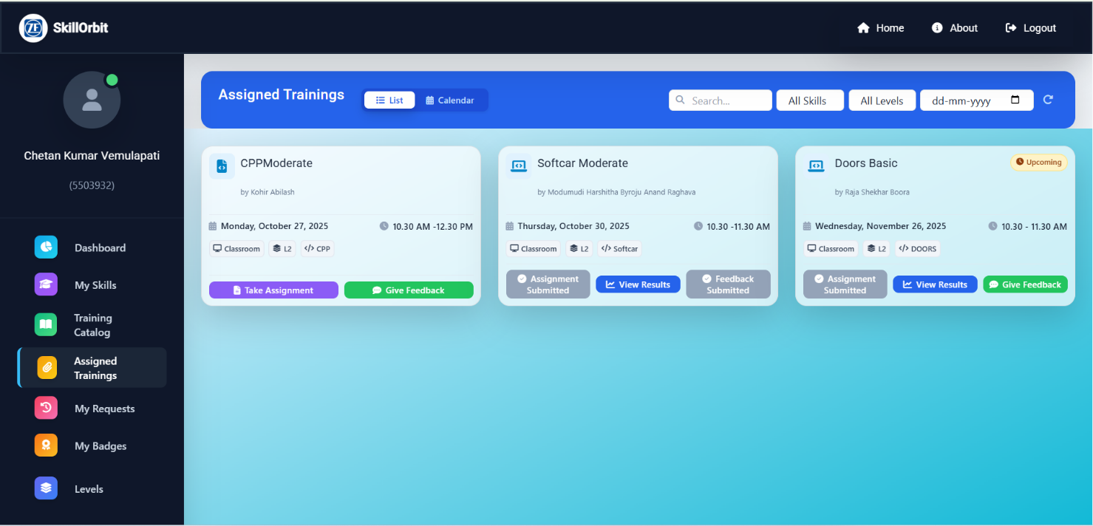

**Fig 9: Assigned Trainings Page**

**4.3.8 My Badges Module**

This module displays badges earned by users based on skill completion and performance.

* Badges are awarded automatically upon meeting certain criteria.
* Both engineers and managers can view their earned badges and levels of achievement.

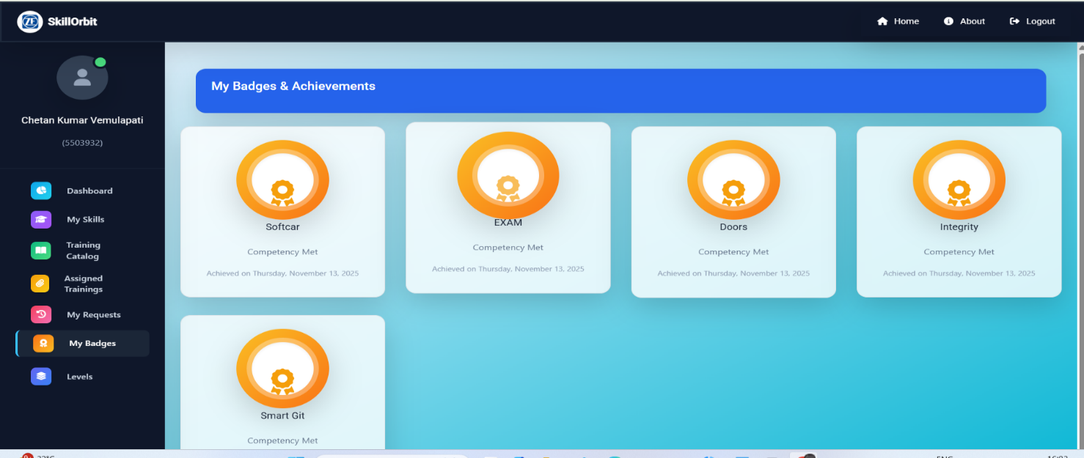

**Fig 10: My Badges Page**

**4.3.9 Assign Training Module (Manager Specific)**

This module allows managers to assign trainings directly to their team members.

* Managers can select multiple engineers and assign one or more trainings at a time.
* A notification is sent to the assigned employees.
* The system updates the status automatically upon completion.

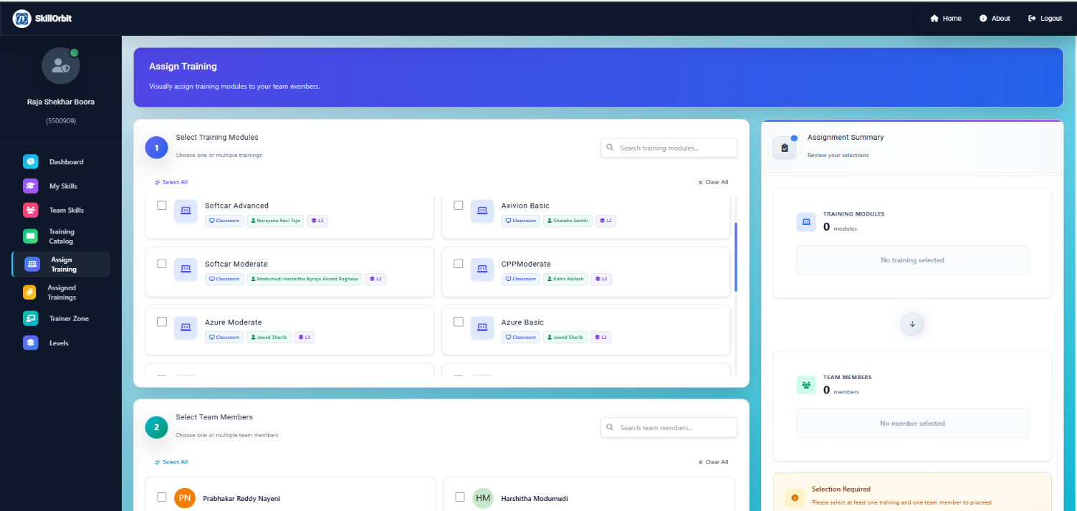

**Fig 11: Assign Training Page**

**4.3.10 Team Skills Module (Manager Specific)**

The Team Skills Module provides an overview of all team members’ competencies.

* Displays each engineer’s current and target skill levels.
* Helps managers identify skill gaps and recommend relevant trainings.
* Supports exporting team skill data for performance analysis.

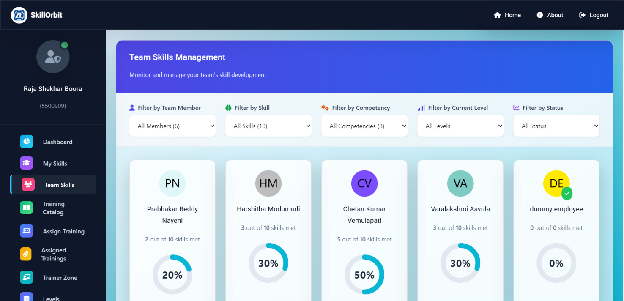

**Fig 12: Team Skills Page**

**4.3.11 Levels Module**

The **Levels Module** defines and displays the competency levels used within the system.

* Each skill is categorized under one of five levels (L1–L5).
* Users can refer to level descriptions to understand required expectations.
* Ensures consistent evaluation standards across teams.

**Typical Level Definitions:**

* **L1 – Basic Understanding:** Awareness of basic concepts and terminology.
* **L2 –Basic:** Ability to perform tasks under supervision.
* **L3 – Intermediate:** Independently handles tasks and provides reliable outputs.
* **L4 – Advanced :** Deep understanding and ability to guide others.
* **L5 – Expert:** Recognized subject expert capable of mentoring and designing strategies.

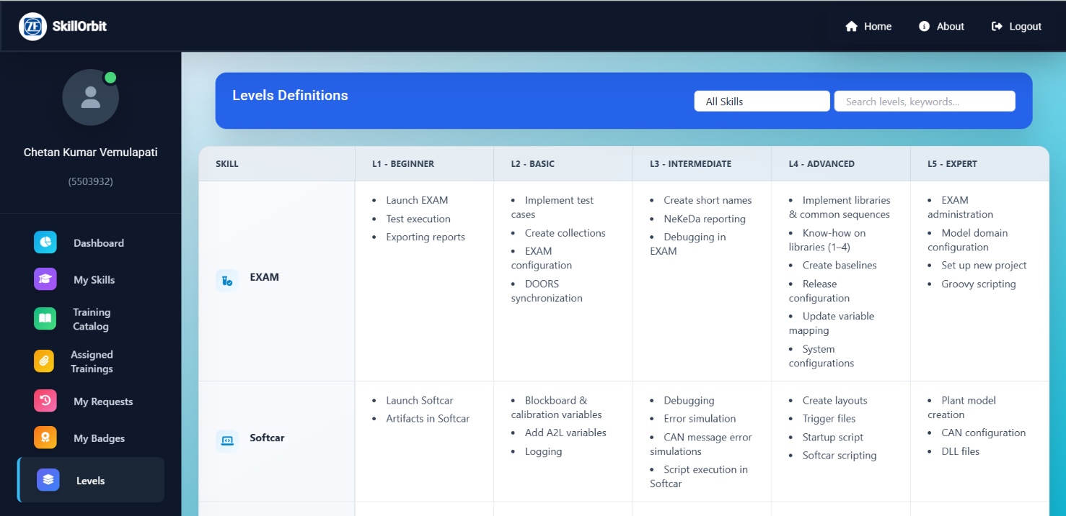

**Fig 13: Levels Page**

**4.3.12 My Requests Module**

The **My Requests Page** displays all the training requests raised by employees and their approval status.

* Engineers can track whether their requests are approved or pending.
* Managers can view, approve, or reject requests from this page.

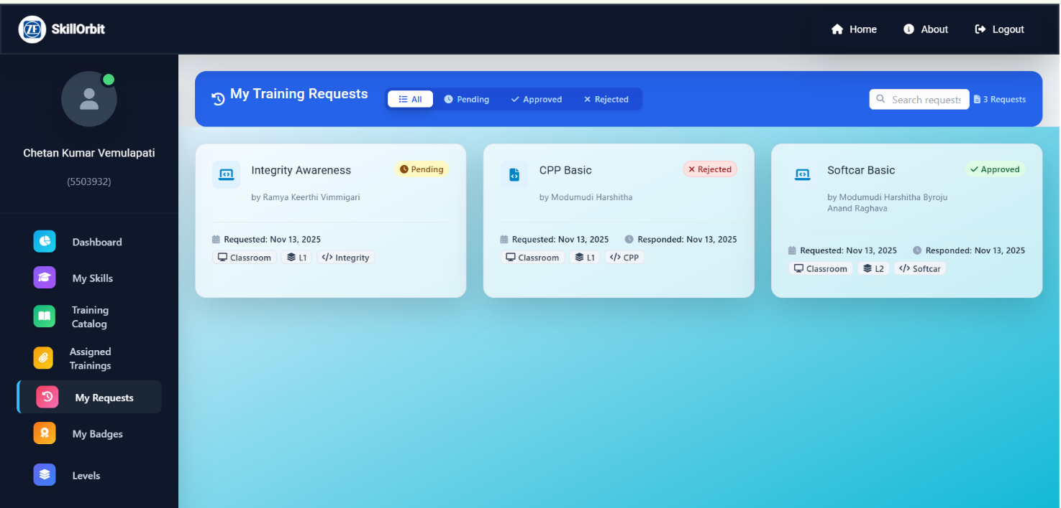

**Fig 14: My Requests Page**

**4.3.13 Team Dashboard (Manager Specific)**

The **Team Dashboard** consolidates all team-related insights.

* Displays team size, skill statistics, and average progress.
* Allows managers to compare skill growth across different team members.

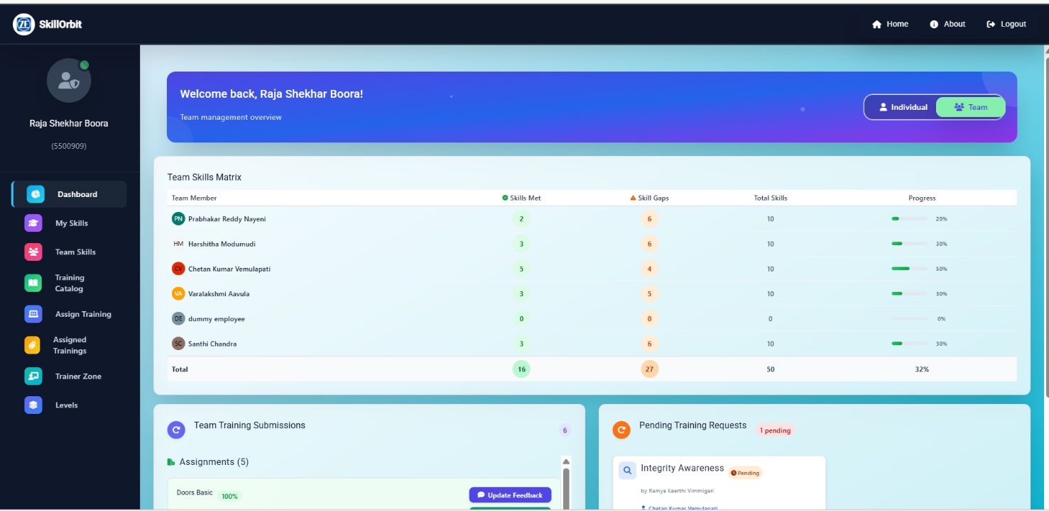

**Fig 15: Team Dashboard Page**

**4.6 Conclusion**

The implementation of **Skill Orbit – Competency Management Ecosystem** successfully integrates multiple modules into one streamlined platform. It automates the skill development workflow, simplifies training administration, and enhances communication between managers and employees.

The system provides a secure, scalable, and user-friendly solution that supports data-driven employee development and efficient organizational growth.

## Chapter – 5

**FUTURE ENHANCEMENTS AND IMPROVEMENTS**

**5.1FUTURE ENHANCEMENTS**

The Skill Orbit platform has been successfully developed with essential functionalities like skill tracking, training management, competency-level mapping, and feedback mechanisms. However, there are several potential enhancements that can make the system more intelligent, interactive, and adaptable to large-scale enterprise requirements.

The following are the proposed future enhancements:

**1. Machine Learning–Based Training Recommendations**  
Integrate machine learning algorithms to automatically recommend relevant training programs to employees based on their skill history, performance patterns, and target competencies.

**2. Predictive Skill Gap Analysis**  
Incorporate data analytics and predictive models to identify upcoming skill gaps in teams and suggest proactive training plans to bridge them before performance is impacted.

**3. Advanced Analytics Dashboard**Add detailed analytics with interactive charts and performance metrics that help managers track progress, compare skill trends, and measure training effectiveness in real time.

**4. Mobile Application Support**Develop dedicated mobile applications for Android and iOS platforms to allow users to access Skill Orbit on the go — tracking trainings, skill progress, and feedback from anywhere.

**5. AI-Powered Feedback Analysis**  
Utilize Natural Language Processing (NLP) to analyze feedback and automatically derive insights related to employee performance and training impact.

**6. Multi-Language and Accessibility Support**Expand the platform to support multiple languages and improve accessibility features to cater to diverse, global users.

**7.Automated Notifications and Scheduling**Enhance the notification system to send automated reminders for upcoming trainings, pending tasks, and newly added skill modules using real-time push notifications.

## Chapter – 6

**CONCLUSION**

The **Skill Orbit – Competency Management Ecosystem** has been developed as a comprehensive platform designed to simplify and digitalize skill management, training assignments, and competency tracking in an organization. The system integrates a user-friendly frontend with a robust backend, ensuring smooth interaction between managers and engineers.

By implementing modules such as **Authentication**, **Engineer Dashboard**, **Manager Dashboard**, **My Skills**, **Levels**, **Training Catalog**, **Assigned Trainings**, **My Badges**, **Assign Training**, and **Team Skills**, the platform delivers a unified solution for effective employee development.

The project successfully demonstrates the potential of full-stack web technologies — **Angular**, **FastAPI**, and **PostgreSQL** — in creating scalable, data-driven, and automated enterprise applications. It not only improves operational efficiency but also enhances transparency and collaboration between employees and managers.

The platform can serve as a foundation for future innovations in **AI-driven skill development**, **performance forecasting**, and **automated career path planning**. With continuous improvements and future integration of intelligent features, **Skill Orbit** can evolve into a complete digital competency ecosystem that aligns workforce skills with organizational goals.

**Chapter - 7**

## REFERENCES

1. Angular Official Documentation – <https://angular.io/docs>
2. FastAPI Official Documentation – <https://fastapi.tiangolo.com>
3. PostgreSQL Official Documentation – <https://www.postgresql.org/docs>
4. SQLAlchemy Documentation – <https://docs.sqlalchemy.org>
5. Tailwind CSS Documentation – <https://tailwindcss.com/docs>
6. Mozilla Developer Network (MDN). Web Technologies Documentation – <https://developer.mozilla.org>
7. W3Schools. HTML, CSS, and JavaScript Tutorials – <https://www.w3schools.com>
8. GeeksforGeeks. Full Stack Web Development using Angular and FastAPI – <https://www.geeksforgeeks.org>
9. Stack Overflow Discussions – Community-based solutions for Angular, FastAPI, and PostgreSQL integration – <https://stackoverflow.com>
10. Medium Articles – Competency Management Systems and Modern Training Automation Techniques – <https://medium.com>